Measles Outbreak Investigation in District Lahore, Punjab, Pakistan-2023

Introduction:
Among vaccine preventable diseases, Measles is a highly contagious disease which caused approximately 140,000 deaths worldwide in 2010.Measles (sometimes known as rubeola) is a highly infectious viral illness. It causes a range of symptoms including fever, coughing and distinctive red-brown spots on the skin. The measles virus is contained in the millions of tiny droplets that come out of the nose and mouth when an infected person coughs or sneezes. You can catch measles by breathing in these droplets or, if the droplets have settled on a surface, by touching the surface and then placing your hands near your nose or mouth.
The first sign of measles is usually a high fever, which begins about 10 to 12 days after exposure to the virus, and lasts 4 to 7 days. A runny nose, a cough, red and watery eyes, and small white spots inside the cheeks can develop in the initial stage. After several days, a rash erupts, usually on the face and upper neck. Over about 3 days, the rash spreads, eventually reaching the hands and feet. The rash lasts for 5 to 6 days, and then fades. On average, the rash occurs 14 days after exposure to the virus (within a range of 7 to 18 days).
Most measles-related deaths are caused by complications associated with the disease. Serious complications are more common in children under the age of 5, or adults over the age of 30. The most serious complications include blindness, encephalitis (an infection that causes brain swelling), severe diarrhoea and related dehydration, ear infections, or severe respiratory infections such as pneumonia. Severe measles is more likely among poorly nourished young children, especially those with insufficient vitamin A, or whose immune systems have been weakened by HIV/AIDS or other diseases.
In populations with high levels of malnutrition, particularly vitamin A deficiency, and a lack of adequate health care, about 3–6%, of measles cases result in death, and in displaced groups, up to 30% of cases result in death. Women infected while pregnant are also at risk of severe complications and the pregnancy may end in miscarriage or preterm delivery. People who recover from measles are immune for the rest of their lives.
Background:
On 19th June 2023, Measles outbreak case response campaign started in 10 districts of Punjab for children from 06th months to less than five years in ten selected districts Gujranawala,Hafizabad,Jhang,Kasur,Lahore,Narrowal,Rawalpindi,Sheikhupura,Sialkot and TT Singh. In response to this; Director General Health Services constituted a team comprising of Additional Director Health Services (ADHS) MIS Punjab, Medical Officer(MO) EPI, and Director General Health Management team Punjab. Objectives of the field visit and outbreak investigation were to assess the magnitude of outbreak, to determine the cause and to recommend the preventive measures in order to control the outbreak and to conduct the case response campaign.
Methodology:
Field visit Setting: The Measles/Rubella (MR) Outbreak Case Response Campaign in 10 selected districts of Punjab. District Lahore assigned to me (Dr M Mohsan Wattoo (Epidemiologist MIS Punjab.
Field Investigation Duration: The field visit was conducted from 19-24th June, 2023.
Case Definition: Sudden onset of fever and maculopapular rash and any one of the following signs and symptoms of cough, coryza and conjunctivitis with laboratory confirmation” presenting between 1st January, 2023 to 19th June 2023 in a resident of District Lahore.
Active case finding was carried out in the respective union council and surrounding vicinity. The data was collected using a semi structured questionnaire from house to house active case finding search. The data was taken on demographic variable, clinical signs and symptoms, vaccination history and risk factor being imparted. All the data was put on excel spreadsheet and analysis was done. Quantitative data was cleaned and coded. Frequencies were calculated and tables / graphs generated using Epi Info 7.0®. Risk factor associations were also analyzed.
Active Case Finding:
The active case finding was conducted in the community by administering a pre-tested questionnaire to the guardians of measles cases. Information was collected on demographics, disease notification, clinical presentation, and vaccination status and disease outcome. Information collected was based on respondent’s recall, hospital discharge card and vaccination card. Apart from active case finding.
Results:
Total 1140 Suspected cases and 495 confirmed cases were identified in the district Lahore by district line listing and active case finding. Town-wise cases details given below.

Most affected Town is Samanabad (265) Town and Allama Iqbal (!23Town,

Total covered UC’s in Punjab are 147 & Cumulative 6 days target was 1,407,907 out of which 1,386,178 Target Children Vaccinated 6-59 Months which is around 98.6 percent

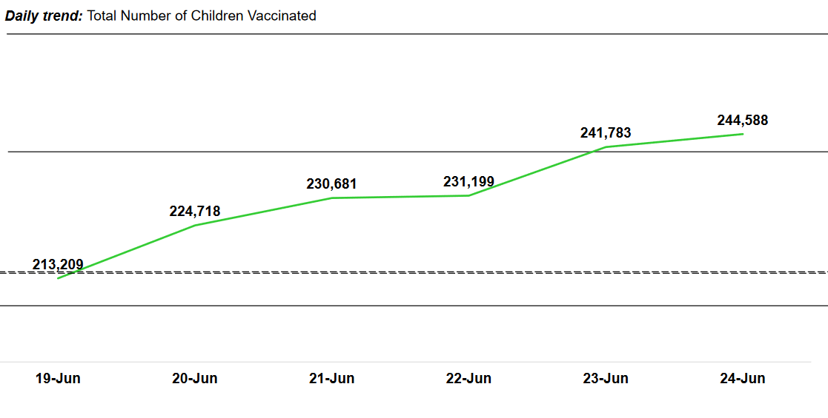

Measles / Rubella Outbreak Cases Response Campaign from 19-24 June 2023
District | Total UCs | Cumulative 6 days targe | Target Children Vaccinated 6-59 Months | Percentage
Lahore | 80 | 1,002,923 | 989,491 | 99%

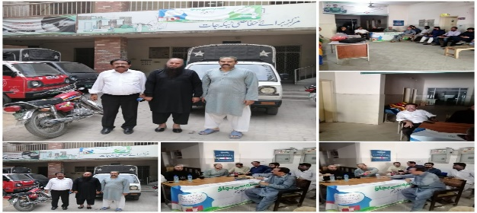
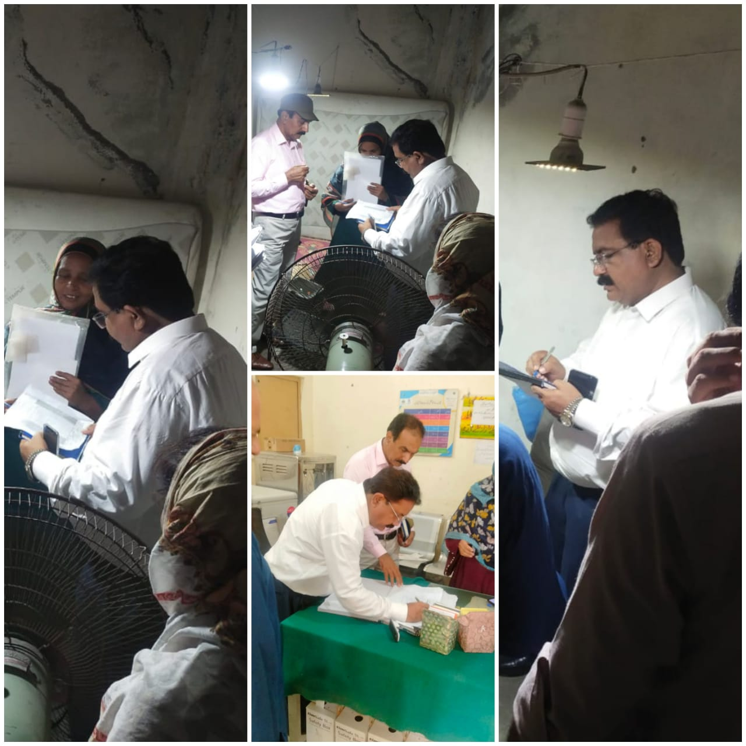
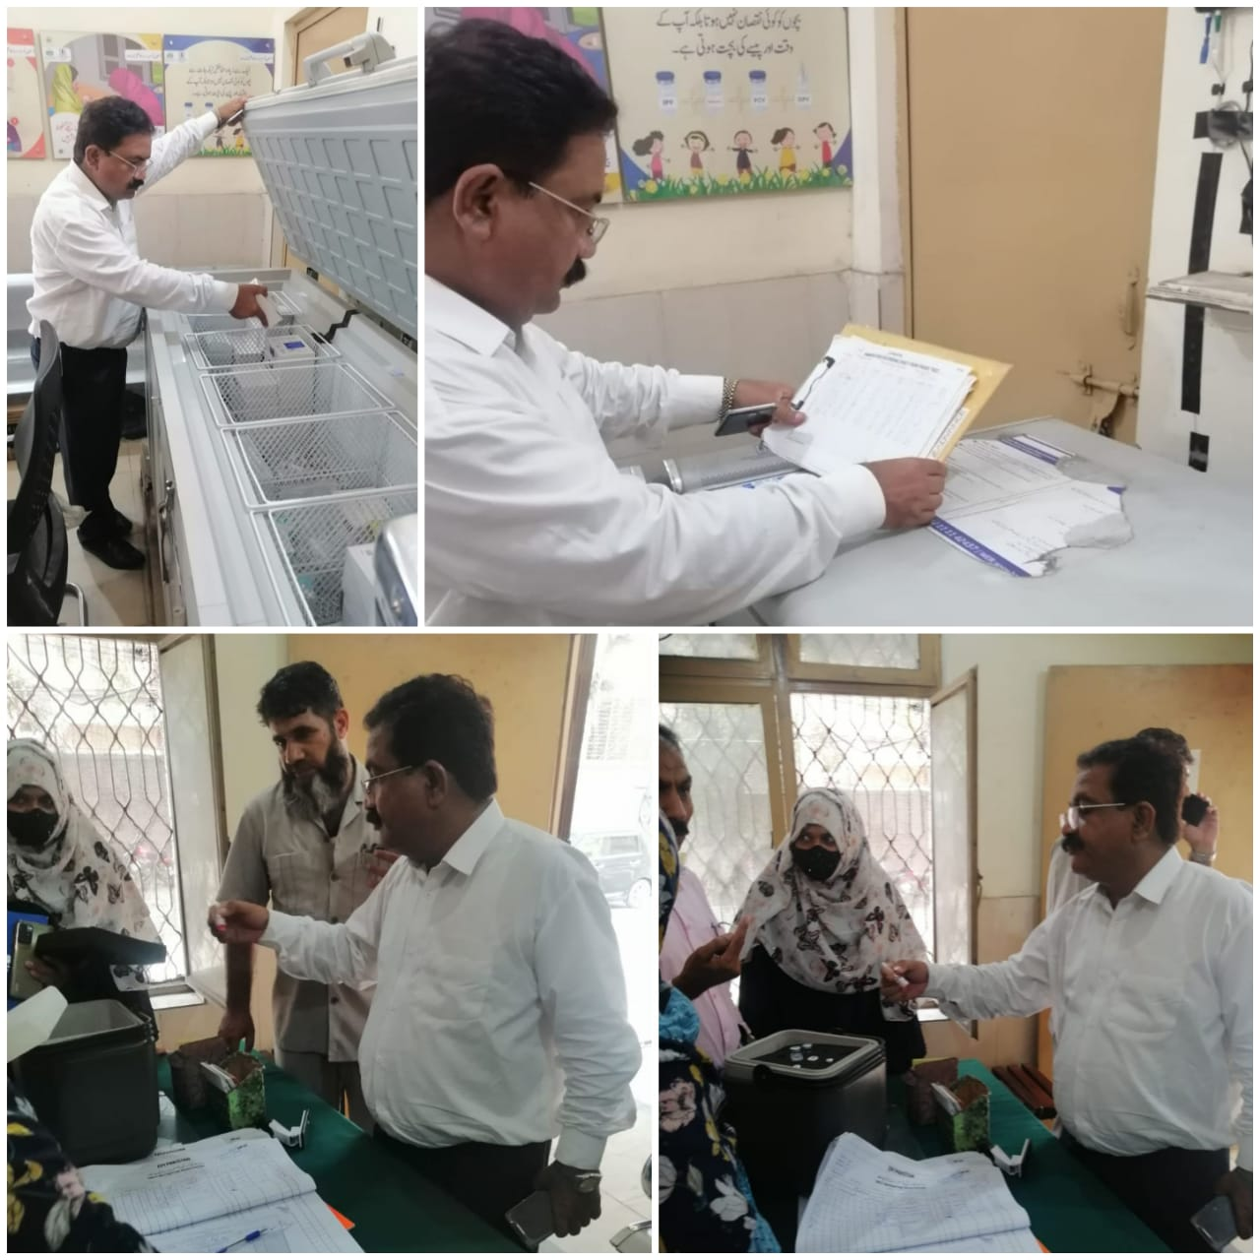
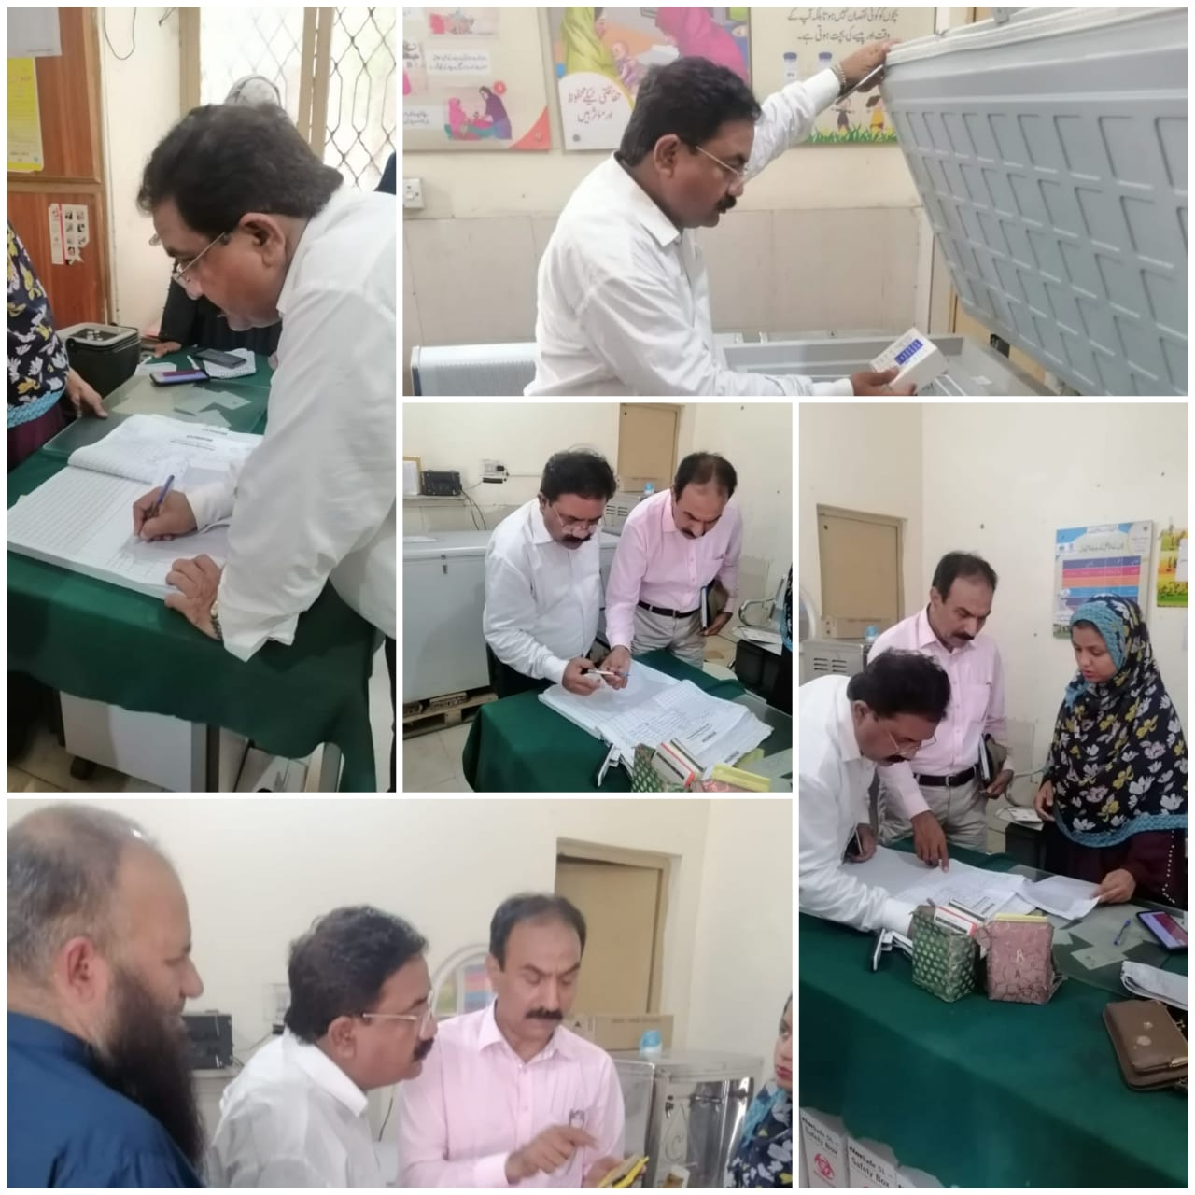
CONCLUSION:
The investigator reported that this measles outbreak in Union Councils, Tehsil & District Lahore, was largely due to increased susceptible children in the community. The susceptible children were unvaccinated which are highly at risk might be the probable cause of outbreak in the affected Union Council and the surrounding vicinity. In the absence of an integrated surveillance mechanism, the outbreak could not be detected in time. Lack of effective monitoring mechanisms and VPD surveillance together also lead to such a massive outbreak. Policy level interventions are needed to address the gaps in surveillance and routine immunization if such outbreaks are to be prevented in the future
Recommendations
Mop-up activities by DHMT must be done in the affected Union Councils and surrounding vicinity of in the Union Council, Vitamin A shall also be given to all the eligible children. Further it is highly recommended and advised to district team to established a health camp in union councils and surroundings in which the supplementary and routine immunization activities must be expedite to prevent future outbreaks and other VPDs and there should be strong surveillance activities accompanied monitoring and supervision by DHMT.

